*The Toymaker’s Bequest*:

A Defense of Narrative-centric Game Design

By

Jung-Ho Sohn

Master of Fine Arts Interactive Media & Games Division

School of Cinematic Arts University of Southern California May 11, 2018

ProQuest Number: 10792318

All rights reserved

INFORMATION TO ALL USERS

The quality of this reproduction is dependent upon the quality of the copy submitted.

In the unlikely event that the author did not send a complete manuscript

and there are missing pages, these will be noted. Also, if material had to be removed, a note will indicate the deletion.



ProQuest 10792318

Published by ProQuest LLC (2018 ). Copyright of the Dissertation is held by the Author.

All rights reserved.

This work is protected against unauthorized copying under Title 17, United States Code Microform Edition © ProQuest LLC.

ProQuest LLC.

789 East Eisenhower Parkway

P.O. Box 1346

Ann Arbor, MI 48106 - 1346

Acknowledgments 4

List of Figures 5

Abstract 7

Terms and Definitions 8

Introduction 9

Part 1: Discussion on Narrative-centric games 10

* 1. Why does it matter? 10
  2. Game Narrative Types 16
     1. Evocative Spaces 16
     2. Enacting Stories 17
     3. Embedded Narratives 18
     4. Emergent Narratives 20

Part 2: Critique of Narrative-centric Games 21

* 1. Ludonarrative Dissonance 22
  2. Episodic 26
  3. Player Agency 29
  4. Systems Design 32

Part 3: Narrative-centric design with The Toymaker’s Bequest 37

* 1. Concept 37
  2. Prior Art for narrative design 39
  3. Design Methodology 41
     1. Ideation 41
     2. Pre-production 44
     3. Production 46
  4. Feedback 50
     1. Pre-alpha 50
     2. Post-alpha 51
  5. Lessons and Difficulties 54
     1. Scope 54
     2. Clarity & Simplicity 55
     3. Generic vs. Expressive 55
     4. Work vs. Play 56

Conclusion 57

Works Cited 59

# Acknowledgments

Before I begin, I would like to take a moment to thank those that have assisted me throughout the process of creating *The Toymaker’s Bequest*.

Foremost, I would like to express my gratitude to my committee advisors Andreas Kratky, Richard Lemarchand, and Ian Dallas for offering the much needed guidance and insight to push *The Toymaker’s Bequest* to its utmost potential.

I would also like to thank Jane Pinckard, Jeff Watson, and Maureen McHugh for the continued support for this project through their time and validation.

It goes without saying that I would also like to thank Yiwen Dai, my partner in crime, for commiserating with me over the grueling development process. As difficult as things were, it is thanks to your constant strive for excellence that has brought the project to where it is today.

Finally, I would like to thank my family for always encouraging me to pursue my dreams.

# List of Figures

Fig. 1. *Her Story* game interface screen.

Fig. 2. Compilation of screenshots from *Device 6*.

Fig. 3. Intro sequence of *What Remains of Edith Finch*.

Fig. 4. Still from in-game vignette in *What Remains of Edith Finch*. Fig. 5. *Florence*.

Fig. 6. Propaganda Parade in *BioShock Infinite*. Fig. 7. Propaganda Poster in *BioShock Infinite*. Fig. 8. Ludic experience of gunplay in *BioShock*.

Fig. 9. Ludonarrative dissonance of moral choices in *BioShock*. Fig. 10. Action-based gunplay in *Uncharted 3*.

Fig. 11. Stealth-based gameplay in *The Last of Us*. Fig. 12. Masks of commedia del arte.

Fig. 13. *House of Leaves*.

Fig. 14. Meadows’ system example with an energy level of a coffee drinker. Fig. 15. *Super Mario Bros.* level 1.

Fig. 16. *The Cat Lady* coffee level.

Fig. 17. Interactive zoetrope in *The Toymaker’s Bequest*.

Fig. 18. Interactive peephole portraying the main character’s life in *The Toymaker’s Bequest.* Art by Renzel Navarro.

Fig. 19. Opening Sequence in *The Cat Lady*.

Fig. 20. Stills from *The Sensational December Machine*.

Fig. 21. Still from the cannery in *What Remains of Edith Finch*.

Fig. 22. Still detailing interaction mechanic from *The Toymaker’s Bequest.*

Fig. 23. Paper prototyping of the interaction mechanic.

Fig. 24. Mechanical toy view of *The Toymaker’s Bequest’s* vertical slice. Fig. 25. Narrative prototype of *The Toymaker’s Bequest* utilizing Twine.

Fig. 26. Text stubbed in for narrative delivery in *The Toymaker’s Bequest’*s music box level.

Fig. 27. Poster as embedded narrative in *The Toymaker’s Bequest’*s theatre level. Fig. 28. Chest interaction revealing a frog in *The Toymaker’s Bequest*’s theatre level. Fig. 29. View of the water tank in *The Toymaker’s Bequest’*s theatre level.

Fig. 30. Character’s reappearance upon interacting with the closet in *The Toymaker’s Bequest.*

Fig. 31. Opening sequence of *The Toymaker’s Bequest*’s theatre level.

# Abstract

In response to criticism of video games as a narrative medium, this document discusses the innovative potential of narrative-centric design where the creator’s authorial voice to tell stories is the driving force of development. Drawing from prior narrative-centric works and research on narrative in games, this document argues that videogames are not only capable of telling compelling stories, but also that videogames have already established a medium specific method of storytelling that validates narrative-centric design. Divided into three parts, the first part will offer a brief overview of the value of narrative-centric games and the unique storytelling potentials of the interactive medium. Part two will review common criticisms against narrative-centric games such as ludonarrative dissonance, player agency, and systemic design.

Finally, using the author’s own development experience of a narrative-centric game, *The Toymaker’s Bequest*, part three will discuss the unique design methods and challenges of a narrative-centric design.

**Terms and Definitions Story**: A sequence of events.

**Narrative:** The method or means of telling a sequence of events to convey meaning.

**Narrative-centric Games:** Games that “focus more on the narrative and the kinds of emotional experiences associated with narrative in the verbal and visual arts, emphasising the player’s interaction with and participation in a story”. Importantly, “whilst containing ludic components that are integral to the delivery of the narrative”, narrative-centric games “do not foreground the process of play as the sole, or even the most, important aspect of their make-up” (Stobbart, 14)..

**Game Mechanics:** Discrete formal aspects of a game in the form of rules designed for interacting with a game to create gameplay. Given the context, mechanics will also be referring to game mechanics unless explicitly specified.

**Gameplay:** The often ludic outcome of the interaction and combination of a game’s formal elements, or the game mechanics.

**Game System:** A system according to Donnella Meadows in *Thinking in Systems* is “an interconnected set of elements that is coherently organized in a way that achieves something” (11). As such a game system is an interconnected set of game mechanics that is coherently organized in a way that achieves gameplay.

# Introduction

In the academics of games studies, there has been an ongoing debate between ludology, the study of games, and narratology, the study of narratives. While the ludologists place an emphasis on the study of games as formal systems such as the game mechanics and gameplay, the narratologists view games as a new form of narrative that should be studies as such. Though a somewhat dated debate, a recent surge of narrative-centric games has led to the resurfacing of this classic debate on the validity of narrative-centric games.

In response, this paper will discuss the topic of narrative-centric game design in three parts. Part one will discuss the characteristics of narrative-centric games and the validity of a narrative-centric game design process. Though this discussion may expand to all forms of interactive media, this paper will focus on video games. Part two will address some of the prominent critiques of narrative-centric games and deconstruct the arguments. Finally, part three will discuss a case study of the author’s own narrative-centric game design process with the game, *The Toymaker’s Bequest*.

Sohn 10

# Part 1: Discussion on Narrative-centric games

* 1. *Why does it matter?*

Traditionally, games have leaned towards ludic experiences as noted by the defining of game genres through their mechanics. In contrast, the focus on narrative-centric games is relatively new. Yet, a few commonly stated arguments can help give a glimpse at the significance of narrative-centric games for the games community.

First, narrative-centric games offer additional means for developers to inject authorial voices into their creative expressions resulting in a greater diversity in games. All creative works have a trace of the creative intent, such as a game mechanic conveying a particular feeling.

However, the interpretation of these feelings are limited to the personally lived or salient experiences of the player. Giving creators authorial control over the narrative can serve as an accessible anchor for addressing complex and diverse themes beyond the scope of familiarity.

Second, innovation through narrative has always been one of the major facets of innovation in a creative medium. Expertly worded by Mata Haggis,

We are supposed to be working in an industry that values the creation of new and exciting ideas, but we are facing a problem: as the money spent to improve graphics begins to have smaller and smaller effects on the final game, the search for innovation must come from other areas. Gameplay mechanics are one area where innovation is possible, but new genres and really significant changes are becoming rare. Visual experimentation away from realism is another path we are taking, but most of all we are

in a position where innovation is frequently being pushed onto the game’s narrative. This is a place where historically games have performed very poorly, but where there are proven examples of the same story being retold in new ways for hundreds of years. (Haggis)

A game mechanic on its own can only go through a few variations before it begins to feel derivative. In contrast, a game mechanic in service of a narrative, where every lived experience has a unique story tied to it, takes on new meanings that feel different every iteration. In other words, innovation through narrative is easier than the oversaturated innovation through game mechanic.

Third, existing game mechanics are already ripe with narrative potential. Games have not always lend itself to linear storytelling, but games have always told stories, just not in the ways most people notice as stories. As described by Jenkins, “the early Nintendo games have simple narrative hooks - rescue Princess Toadstool - but what gamers found astonishing … were their complex and imaginative graphic realms … we situate them alongside a much older tradition of spatial storytelling” (Jenkins 4). I will further expand on the unique advantages of games as spatial storytelling shortly.

Finally, there is an audience for narrative-centric games that have always existed.

Traditionally ludic game genres like platformers and shooters may first come as those that have enjoyed a dominant presence in the industry, but narrative-centric adventure games have also shared an era in the limelight with studios such as Lucas Arts and Sierra focusing on these games. Not only that, but the advent of new narrative-centric game development tools like Twine

have lowered the barrier of entry for game development. This resulted in a resurgence of narrative-centric games on the market as well as the surfacing of a corresponding audience. This clearly signifies that regardless of the games communities evaluation of narrative-centric games, there is an audience ready to consume such content.

In an article titled *Video Games Are Better Without Stories*, Ian Bogost concludes, “If there is a future of games, let alone a future in which they discover their potential as a defining medium of an era, it will be one in which games abandon the dream of becoming narrative media” (Bogost). Though Bogost’s conclusion is a valid one that speaks to many sentiments within the games community, it is hard not to see his argument as flawed in its partial interpretations of narratives. Drawing from Henry Jenkins’ discussion on ludologists,

A series of conceptual blind spots prevent them from developing a full understanding of the interplay between narrative and games. First, the discussion operates with too narrow a model of narrative, one preoccupied with the rules and conventions of classical linear storytelling at the expense of consideration of other kinds of narratives … Second, the discussion operates with too limited an understanding of narration, focusing more on the activities and aspirations of the storyteller and too little on the process of narrative comprehension. Third, the discussion deals only with the question of whether whole games tell stories and not whether narrative elements might enter games at a more localized level. Finally, the discussion assumes that narratives must be self-contained rather than understanding games as serving some specific function within a new transmedia storytelling environment. (Jenkins 3)

Taking these blind spots into consideration, games are not only a viable form of narrative media, but they are an area of games that has been flourishing with progress unique to the interactive medium. To name a few, Sam Barlow’s *Her Story*, a game about combing through old police interrogation footage to uncover the stories surrounding a murder case, seamlessly interweaves narrative excavation with mechanical constraints (see fig. 1). By establishing an interplay between predefined truth with perceived truth, the player’s negotiations with the game system plays an active role of forming the narrative experience. In Simogo’s *Device 6*, a

text-based adventure game, the textual space literally exists as a spatial environment to be navigated, blurring the distinction between the player’s temporal and spatial engagement with the narrative (see fig. 2). Finally, Giant Sparrow’s *What Remains of Edith Finch*, a collection of short interactive stories about a cursed family, displays a masterful execution of game mechanics enhancing narrative to deliver a truly affecting experience lauded as the pinnacle of its genre (see fig. 3 and 4). These are only a few examples of games focusing on ludonarrative experiences with more innovations continuously being made with new releases, and all of these games have contributed to the expanding language of game design.

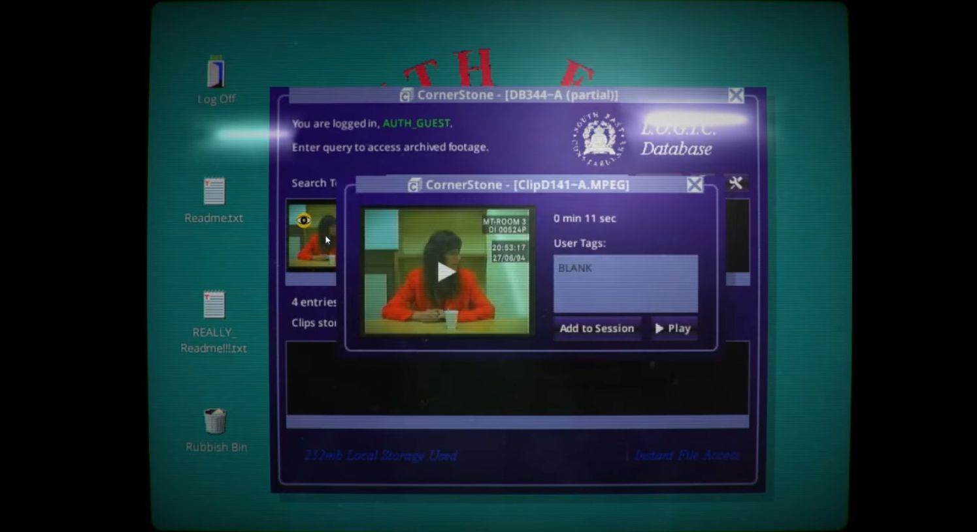

Fig. 1. *Her Story* game interface screen (Barlow).



Fig. 2. Compilation of screenshots from *Device 6* (Simogo, “Device 6”).



Fig. 3. Intro sequence of *What Remains of Edith Finch* (Giant Sparrow).

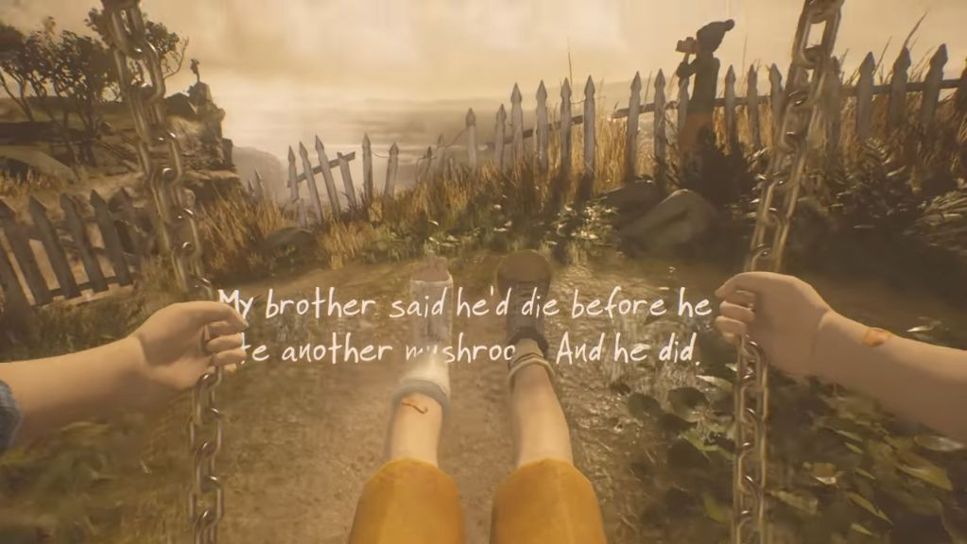

Fig. 4. Still from in-game vignette in *What Remains of Edith Finch* (Giant Sparrow).

* 1. *Game Narrative Types*

Returning to Jenkins, he further posits that games have always had a unique method of storytelling through spatiality, arguing “for an understanding of game designers less as storytellers and more as narrative architects” (3). In order to facilitate discussion, I would like to take a moment to expand upon some of the means of immersive narrative experiences listed by Jenkins as I believe many of these narrative types serve the basis of narrative-centric game experiences.

# Evocative Spaces

Jenkins defines evocative spaces as narrative spaces that “draw upon our previously existing narrative competencies” comparable to “amusement park attractions [that] build upon stories or genre traditions already well known to visitors” (6). In games, a common form of evocative spaces are the usage of sci-fi and fantasy worlds and expanding them into spatially navigable environments. By building upon pre-existing knowledge of a space, player’s can experience complex narratives in worlds that are drastically different from their own reality without the need for excessive introduction. Furthermore, evocative spaces can also be used to facilitate everyday narratives by leveraging relatable themes of human existence. For example, *Florence*, a mobile narrative experience by Mountains, seeks to tell a story about falling in love, an experience most people may recognize as their own (see fig. 5). Despite *Florence*’s usage of the potentially unclear visual storytelling technique, the game uses familiar imagery drawn from the shared knowledge-base of falling in love to convey narrative information with ease.



Fig. 5. *Florence* (Mountains).

# Enacting Stories

Enacting stories are a means of storytelling where the player enacts narrative events through their progression. This type of spatial narrative privileges “spatial exploration over plot development … held together by broadly defined goals and conflicts … so that obstacles thwart and affordances facilitate the protagonist’s forward movement towards resolution” (Jenkins 7). Since the enacted narrative events are determined by the player’s navigation of the space, these stories tend to exist as discrete moments that can exist on their own as well as having flexibility in their ordering. Although the disjointed characteristic of enacting stories may appear as bad storytelling, the strength of these stories come in their layering on top of another to create

narrative depth. This action mirrors a player’s mental model described by Oh in her narrative-centric design model of constructing narrative layers:

One could say that when the player presses “start” of [sic] a game, she gets thrown into an unfamiliar world. She does not have prior knowledge about this world, nor has formed any attachment to it. What she is probably going to do, is to interact with the surrounding world, deliberately chosen and designed by the designer, in order to form an understanding of what this world is and what her relationship is to it. (Oh 20)

As such, enacting stories rely on a negotiation between the player’s conceptualization of the narrative space with the rules of the world to deliver a narrative experience focused on the process of comprehension..

# Embedded Narratives

While enacting stories demands the player’s attention to take an active role in triggering narrative events linked to a broadly defined goal of progression, embedded narratives are a much more passive means of narrative engagement. Embedded narratives are similar to a body of narrative cues scattered throughout the game space that greatly contribute to building the game world. For example, the propaganda posters in the environment of Irrational Games’ *BioShock Infinite* help establish the class struggles in this world, or the demented utterances of the enemy characters in From Software’s *Bloodborne* illustrates a dilapidated village suffering from collective madness (see fig. 6). Many of these embedded narratives are missable due to being

supplemental content that often fades into the surrounding environments. Furthermore, many embedded narratives exist in contested spaces where narrative comprehension is not the primary goal such as the environments in *BioShock Infinite* where the primary purpose is to shoot through waves of enemies (see fig. 7). Still, “a mixture of enacted and embedded narrative elements can allow for a balance between the flexibility of interactivity and the coherence of a pre-authored narrative” (Jenkins 10).



Fig. 6. Propaganda Parade in *BioShock Infinite* (Irrational Games, “BioShock Infinite”).

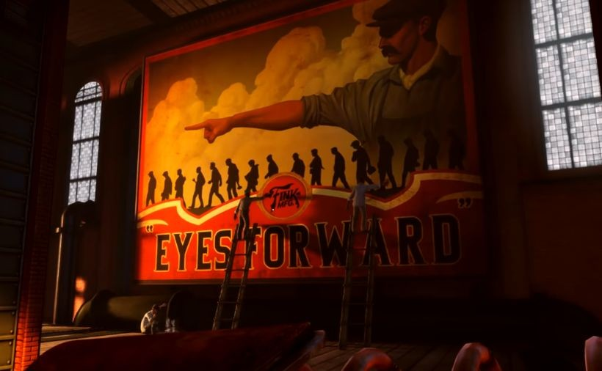

Fig. 7. Propaganda Poster in *BioShock Infinite* (Irrational Games, “BioShock Infinite”).

# Emergent Narratives

According to Jenkins, emergent narratives are game spaces “designed to be rich with narrative potential, enabling the story-constructing activity of players” (13). Jenkins further details an example as “Will Wright frequently describes The Sims as a sandbox or dollhouse game, suggesting that it should be understood as a kind of authoring environment within which players can define their own goals and write their own stories” (11). Other than simulation games, competitive games also have rich emergent narrative potential as the non-scripted characteristic of competitive play makes each player’s experience unique.

Compared to other narratives, emergent narratives have a prominent ludic character as the narrative is less concerned with predefined authorship and more focused on gameplay possibilities using game mechanics within a game system. Unsurprisingly, this allows emergent narratives to be one of the most economic methods to tell stories in games with the sheer volume of stories that can be told from a single game system. The countless stories circulating online through video sharing sites or streaming sites of popular competitive games should serve as testament to the emergent narrative potential of these games.

Despite the seemingly endless possibilities, in emergent narratives, the creator has the least control over the unfolding of the narrative. It can be argued that emergent narratives still provide creator authorship in the form of game mechanics serving as constraints to what actions are permitted, but there are difficulties in conveying specific meanings, which is where the contested issues in narrative-centric games exist. In the next section, I will further investigate the common points of contention in narrative-centric games.

# Part 2: Critique of Narrative-centric Games

Throughout the years of debating between the ludologists and narratologists, many arguments have been raised in critique of games as a narrative medium. Many, such as Bogost have claimed the efforts towards storytelling in games as a fruitless obsession fueled by a misguided cinema envy among game developers. Furthermore, Bogost professes that, “to use games to tell stories is a fine goal, but it’s also an unambitious one” (Bogost). And time and time again, these criticisms have been disproved with innovations in narrative-centric games. The following are a few of the commonly debated issues with narrative-centric games.

* 1. *Ludonarrative Dissonance*

Like any creative craft, many game developers have a strong desire for perfection. Each discrete component of a game is meticulously crafted to be pieced together into a unified whole that seamlessly coalesces into an experience that perfectly embodies the creator’s vision.

Unfortunately, this is a difficult task to execute and the failings to create unity are amplified as dissonance, ultimately breaking the player’s immersion. Among these failings, the ostensibly most egregious is ludonarrative dissonance. Coined by Clint Hocking, ludonarrative dissonance is the conflicting experience of a game’s ludic elements with its narrative elements (see fig. 8 and 9). Hocking, in a critique on *BioShock*, describes “by throwing the narrative and ludic elements of the work into opposition, the game seems to openly mock the player for having believed in the fiction of the game at all” (Hocking).

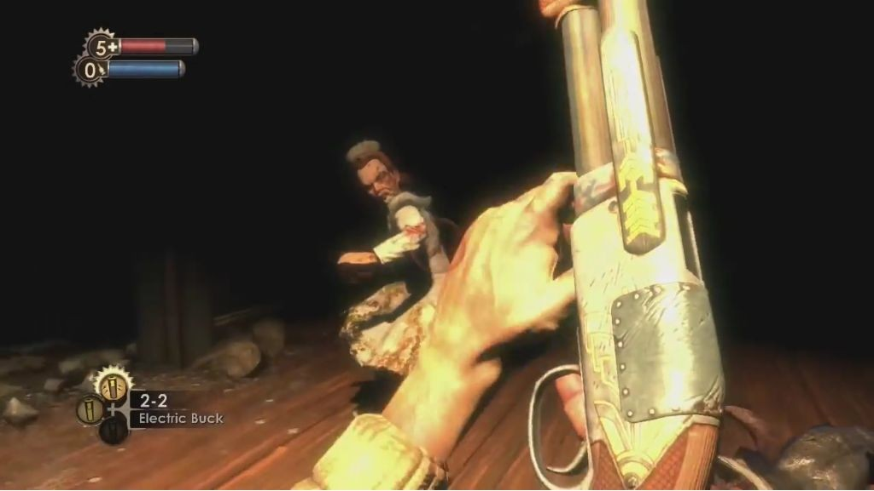

Fig. 8. Ludic experience of gunplay in *BioShock* (Irrational Games, “BioShock”).

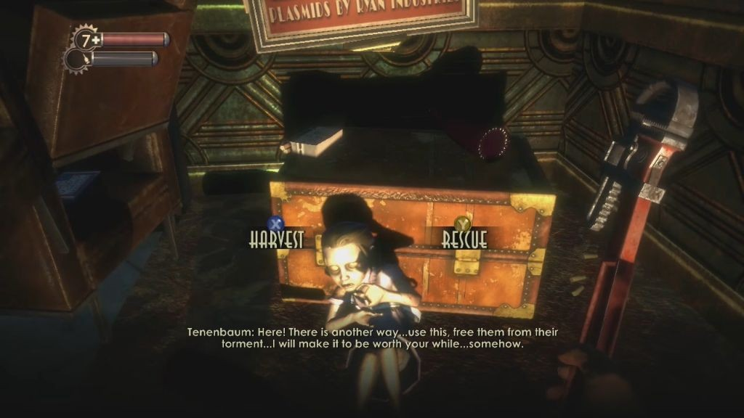

Fig. 9. Ludonarrative dissonance of moral choices in *BioShock* (Irrational Games, “BioShock”).

Ludonarrative dissonance is without a doubt a major issue that has plagued

narrative-centric games and each step towards solving this problem should be celebrated as a major stride for the medium. There is much advice on avoiding ludonarrative dissonance, but among the most common is to begin designing a game’s mechanics before the narrative as it is easier to retrofit the narrative to the game mechanics. This is sound advice in designing a mechanically ludic game experience, but this adage, in addition to the games community’s pressure to mechanically innovate, has stunted game content innovation.

Using the video series, Extra Credits, on narrative game development as a starting point of discussion, the problems of narrative-centric design are due to a limitations in what the

mechanics can be, a limitation to specific sets of characters and places, and an emphasis on plot that pushes development towards an unreasonable scope (“How to Start”).

The first two points stem from the difficulty in designing a fully fledged game mechanic to fit a predefined narrative constraint, but this argument is flawed as the opposite is also true.

Predefining a game mechanic limits the type of narratives that can be told. Moreover, retrofitting a game mechanic to fit a narrative is not an impossibility given the example of games that have similar game mechanics to convey different feelings. For instance, Naughty Dog’s *Uncharted* series and *The Last of Us* are both cover based shooters in function, but these two games show off drastically different feelings appropriate to their respective narratives. *Uncharted* showcases a lighter agile feeling apt for its high-spirited action theming (see fig. 10). In contrast, *The Last of Us* engages the player with a rigid weightiness that reflects the grittier themes of responsibility (see fig. 11). Additionally, the two arguments about the limiting nature of narrative-centric design make a false assumption that decisions in game development are immutable when in reality the iterative nature of game development dynamically adjusts and adapts game elements throughout development. The goal is never to sacrifice a game element, but rather to have a constant negotiation of all elements until everything fits into place. Both narrative and mechanical elements are no exception to this process. As for the final point on narrative driving plot, which in turn pushes development towards an unreasonable scope is more a cautionary tale that can be averted through careful planning rather than inevitable fact.

I understand the concerns expressed in the Extra Credits episode for narrative-centric

games given the relative immaturity of narrative-centric design compared to game mechanics design. There are many hidden problems in narrative-centric design that have not been fully

explored making the process especially daunting. However, when the goal is to innovate games as a narrative medium, this design approach of putting mechanics first is a huge deterring factor. I would go as far as to say that the games community’s insistence on resolving ludonarrative dissonance cripples aspiring developers from taking the necessary risks for true innovation in interactive narratives. Instead of guiding our efforts away from narrative, an appropriate solution may be to educate developers with better narrative design practices such as a realistic understanding of narrative scope in games or the application of iterative design principles in narrative design.

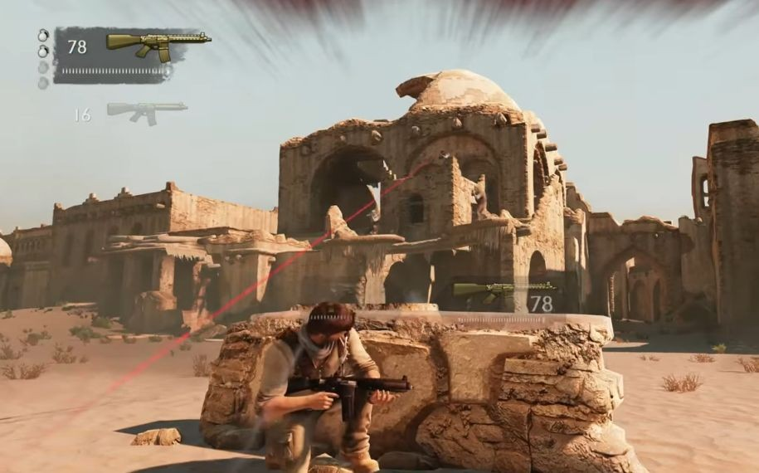

Fig. 10. Action-based gunplay in *Uncharted 3* (Naughty Dog, “Uncharted 3”).

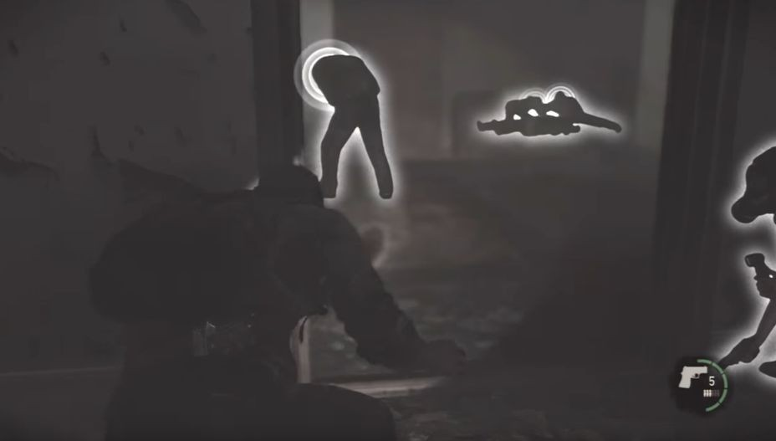

Fig. 11. Stealth-based gameplay in *The Last of Us* (Naughty Dog, “The Last of Us”).

* 1. *Episodic*

A common view of game narratives are how story elements are loosely connected to construct a rather incoherent story focused heavily on spectacle. In order for a game to accommodate player agency, the narrative needs to be self-contained so as to not be tied to linearity for comprehension. The resulting episodic nature, “can become compelling on its own terms without contributing significantly to the plot development and often, the episodes could have been reordered without significantly impacting our experience as a whole”. As discussed by Jenkins as a conceptual blindspot for the ludologist and narratologist debate, this critique of the episodic behaviors of game narratives is a failure to see narrative beyond that of traditional storytelling, missing how “narrative can also enter games on the level of localized incidents”, or “micronarratives”. (Jenkins 7)

To summarize micronarratives are localized narrative incidents where “none of them last more than a few seconds … (and intensifies their emotional impact) through crosscutting between multiple incidents” (Jenkins 7). In a game setting, micronarratives can be any narrative moments that carry emotional impact such as cutscenes or triggered events. Despite the lack of a complex web of interconnectivity, these micronarratives provide players with emotional depth through two different means.

The first is through a broadly defined premise “to create a framework within which localized actions become meaningful” (Jenkins 8). According to research on emotions,

Emotions … are the shortest lived of the affective states. They are generated based on events that have just transpired, and they are related to the goals an individual holds.

Gross [2015] observes that an emotion is expressed if one attends to the event or object in question and then appraises it to be of relevance to a goal one holds. (Harley 35)

In a game, the general premise or goal of the game would inform the appraisal process of narrative events that occur, which in turn produces an emotional impact to the player based on the appraisal. Instances of this practice can also be found in non-interactive forms of narrative media like commedia del arte (see fig. 12). In commedia del arte, a form of masked theatre originating in Italy, characters are loosely defined to the audience based on their masks. “The masks define the relationships between the characters and give us some sense of goals and desires. The masks set limits on the action, even though the performance as a whole is created through improvisation” (Jenkins 8). Commedia del arte, in its improvisational nature, embodies

the same problems as games of having weaker interconnected narrative moments centered around a few key spectacles. However, instead of offering a lackluster experience, “these performance or spectacle-centered genres often display a pleasure in process - in the experiences along the road” (Jenkins 8).

Moving onto the second means for micronarratives to deliver compelling experiences, games can provide emotional depth through repeated exposure. As emotions have been described above, this is an affective state that is short lived. As a result, repeated exposure of self-contained narrative moments can have a compounding effect of layering that provides emphasis on emotional notes as well as mapping out the complexities of a scene.



Fig. 12. Masks of commedia del arte (“Commedia Dell' Arte.”).

* 1. *Player Agency*

Player agency is one of those terms that is hard to pinpoint a universally agreed upon definition. Yet, a lack of player agency is one of the major buzzwords to criticize a game for a perceived lack of purpose. With games as an interactive medium, comes an assumption from players that interacting with the game will return a response. Also, many players will expect their interactions to make an impact or a lasting change to the game system. In the case of ludic games, this would be true as a player’s input directly influences the outcome and progression of the game. For example, think of Nintendo’s *Mario* games, where the player takes direct control of the character’s movement with the game providing a clear feedback of whether the game is won or lost. In contrast, narrative games, especially those with predefined narratives, present players with agency in more subtle ways like dialogue trees or quick time events. Even still, narrative-centric games are frequently criticized for having meaningless interactions that have no bearing or impact on the game.

In response to assertions that narrative-centric games lack player agency, I would like to

discuss how narrative-centric games address player agency through the conceptual act of narrative comprehension. To start off, ignoring how it is debatable whether player agency is even necessary for games, defining player agency as a player’s ability to impact events in a game through choice is a prescriptive definition that fails to acknowledge the various motivations players derive pleasure from games. In Oh’s research, she mentions Lisa Zunshine’s analysis of the pleasures of reading.

The pleasure of reading a story comes from the reader’s mind being constantly stimulated through engaging these representations of textual information on character’s views and feelings; because the reader is capable of thinking in a meta representational capacity, she can see “a pattern behind a series of seemingly unrelated conceptual processes inform our interaction with works of fiction. We begin to recognize that the same cognitive predisposition, that is, our ability to process information under advisement, makes possible both the metamorphosis of the once-proud or prejudiced protagonists into romantic lovers and the metamorphosis of the formerly trusting readers into “detectives” querying the author’s motives. (Oh 15)

Or in the words of Henry Jenkins, “narrative comprehension is an active process by which viewers assemble and make hypotheses about likely narrative developments on the basis of information drawn from textual cues and clues” (9). It is in this process that players are able to exert their agency on the narrative-centric games’ system, receive appropriate feedback for their actions, and ultimately derive pleasure from the experience.

To further support this claim, I would like to take a step back and look to ergodic literature, a non-medium specific function of text where, “non trivial effort is required to allow the reader to traverse the text.”, as clarified by Espen Aarseth (1). A prominent example of an ergodic text would be Mark Z. Danielewski’s *House of Leaves*, as it requires a non trivial effort to traverse the text due to its unconventional formatting that promotes traversal in an almost spatial sense (see fig. 13). It is an experience where “the reader’s ability to exhaustively explore and navigate a network is rewarded with additional narrative content” (Corrigan).



Fig. 13. *House of Leaves* (“House of Leaves.”).

In an analysis of such ergodic literature in the context of video games,

The increasing popularity of video gaming and digital media marks a shift away from the “passive” mode of apprehension engendered by television and non-ergodic literature, and towards a public desire for active participation with media. Within the contemporary media environment, the ludic approach engendered by ergodic texts bolsters the reader’s ability to find self-expression in a state of hybrid-subjectivity. By engendering skills that aid the individual in navigating digital environments, the ergodic smoothes over the commonly-perceived rift between the digital and the textual, suggesting that both platforms can reconcile human agency with systemic design. (Corrigan)

Therefore, “play is posited as an activity that allows for the reader’s manipulations within an authorial design; creating a hermeneutic framework in which agency is not contested, but

co-existent” (Corrigan). In other words, there is play to be found in a player’s agency of interpretation and comprehension of authored works, or in our case, a narrative-centric game.

Even in the most basic forms of narrative traversal, where it may be a simple click to progress mechanic, there is an implicit dialogue that occurs between the player and the game, or system of designed intent. Whereas traditional linear media is a one-sided delivery of the narrative, in an interactive narrative the player takes a conscious action of acknowledgment to progress or trigger a narrative event. Beginning as early as a game’s start screen, each action the player takes provides additional information of the world that compounds in layers to deepen the player’s understanding of the narrative, which in turn serves to inform the next set of actions to be taken.

Harkening back to enacted and embedded narrative systems, these spatial narrative methods exist as scattered information banks that are traversed with the game’s selected navigation mechanic. Returning to the criticism of agency, narrative-centric games may not offer player agency in the ability to affect the game system, but they do offer an opportunity for the player to engage in a kind of narrative excavation, formulating a mental map of the narrative and testing this mental map against the game world.

* 1. *Systems Design* (see fig. 14)

The final critique is an argument that narrative-centric games do not take advantage of the affordances of the medium, or the mechanical system. Similar to the evaluation of games

based on player agency, upholding systems design as the gold standard of games is a prescriptive definition that misses the bigger picture. Systems are a rich area of investigation for game creation, as they are ripe with ludic potential. For instance, Nintendo’s *Super Mario Bros.* has a refined ludic game system, especially when observing the first level (see fig. 15). A lot of discussion has happened about the level design of *Super Mario Bros.*, but the core idea is that a player is placed into a game system where they can poke around distinct game components to receive feedback and gradually map an understanding of the underlying game system to derive ludic pleasure.

To describe how *Super Mario Bros.* achieves this, the player is first presented with a general premise of saving the princess. In this game system, there are certain actions the player can make, like moving and jumping, along with rules on the world’s behavior. Though the game does not make all interaction possibilities immediately obvious, the game presents the player with obstacles that obstruct their progression towards their goal. The game’s desired behavior is to have the player move right while avoiding obstacles. The game manages to guide the player into this behavior by providing appropriate feedback for the player’s actions. If the player walks left, the game will display the character’s inability to move further. If the player moves right, they will be confronted with an enemy that will display a death animation upon contact. As such, the player’s next action would involve avoiding the enemy through the jump action. Later down the line, the player will learn that the jump action can be used to jump onto enemies, jump over pits, and jump onto platforms. Through level design, the player is placed within a sequence of feedback loops where new obstacles are presented that guide players to make informed decisions on the next appropriate action. Like this, the player is placed on a learning curve of gradually

making sense of the game system’s affordances through interaction. This learning continues until the player completes the game, upon which the player would typically have received a sense of achievement and pleasure from the ludic game system.

This type of ludic game system is a powerful tool for generating memorable experiences of play that capitalizes on the interactive potential of the medium, but it is just one of many tools to enrich a game experience and it is not even the only possible game system. Take for instance a narrative system. While a narrative system may not be enforcing a method of play, it can still function as a feedback loop for providing the player with a gradual understanding of the underlying rules of the narrative system, deriving a variety of different experiences. As an example, let us take Harvester Games, *The Cat Lady*, a psychological horror adventure game about a chronically depressed, middle aged woman, that is thrown into undesirable situations after she tries to take her own life. The game shifts back and forth between gruesome images of violence and simple everyday tasks that mirror the frustratingly mundane life of the main protagonist. To specifically illustrate an example of a narrative system, I would like to focus on a scene where the protagonist, Susan Ashworth, tries to relax from a stressful sequence of disturbing events by making coffee for herself (see fig. 16).

The sequence begins by providing the player with the goal of making coffee. In the game

system, the player can walk around and interact with items in the house to achieve her goal. In addition, the player is introduced with two gauges that represent Susan’s stress level and relaxation levels respectively. With these established, the player is free to roam and try to make coffee. Detailing one possible progression, the player may go to the kitchen to make coffee. They will discover a coffee maker and find out that the electricity is not on. In order to make coffee,

the player will have to investigate the lack of power to find that she has not paid her electricity bills, leading to an increase in stress. After paying the bills, the player will return to learn that her mug is missing. The player then may discover old items in the house during the search for the mug, some of which remind Susan of her painful past, resulting in an increased stress level. After finding the mug and returning to the kitchen, the player can heat up the water and make coffee, but upon mixing in milk, they will find that the milk has spoiled, ruining the coffee in the process. As expected, this would again increase Susan’s stress level. This is but one sequence of events that can take place, but it details an interesting use of narrative systems to provide a sense of the world through Susan’s eyes. With the premise of making coffee, the player draws upon their own understanding of the world to make informed decisions on the next appropriate action to make coffee. With each action, the player also receives appropriate feedback that expands the narrative space of what actions are possible and the consequences for these actions. In the case of *The Cat Lady*, the game manages to make the player see the world as Susan does in how a simple task like making coffee can feel like an overwhelming endeavor where you are thwarted every step of the way by some unforeseen misfortune.

Both *Super Mario Bros*. and *The Cat Lady* are system driven games, albeit in slightly

different forms. Both games provide the player with a broadly defined goal and a world with predefined rules. They both present the player with a set of problems that the player must solve with a given set of tools. Finally, both games provide the player with appropriate feedback to actions that help guide the player towards the desired action and emotional experience. From this, I believe it is safe to say that narrative-centric games are as systemically capable as their ludic counterparts.

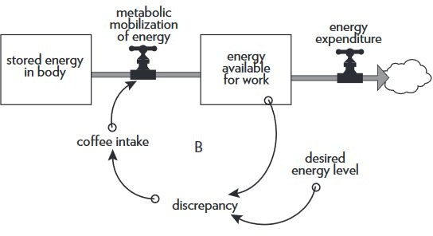

Fig. 14. Meadows’ system example with an energy level of a coffee drinker (Meadows, 27).

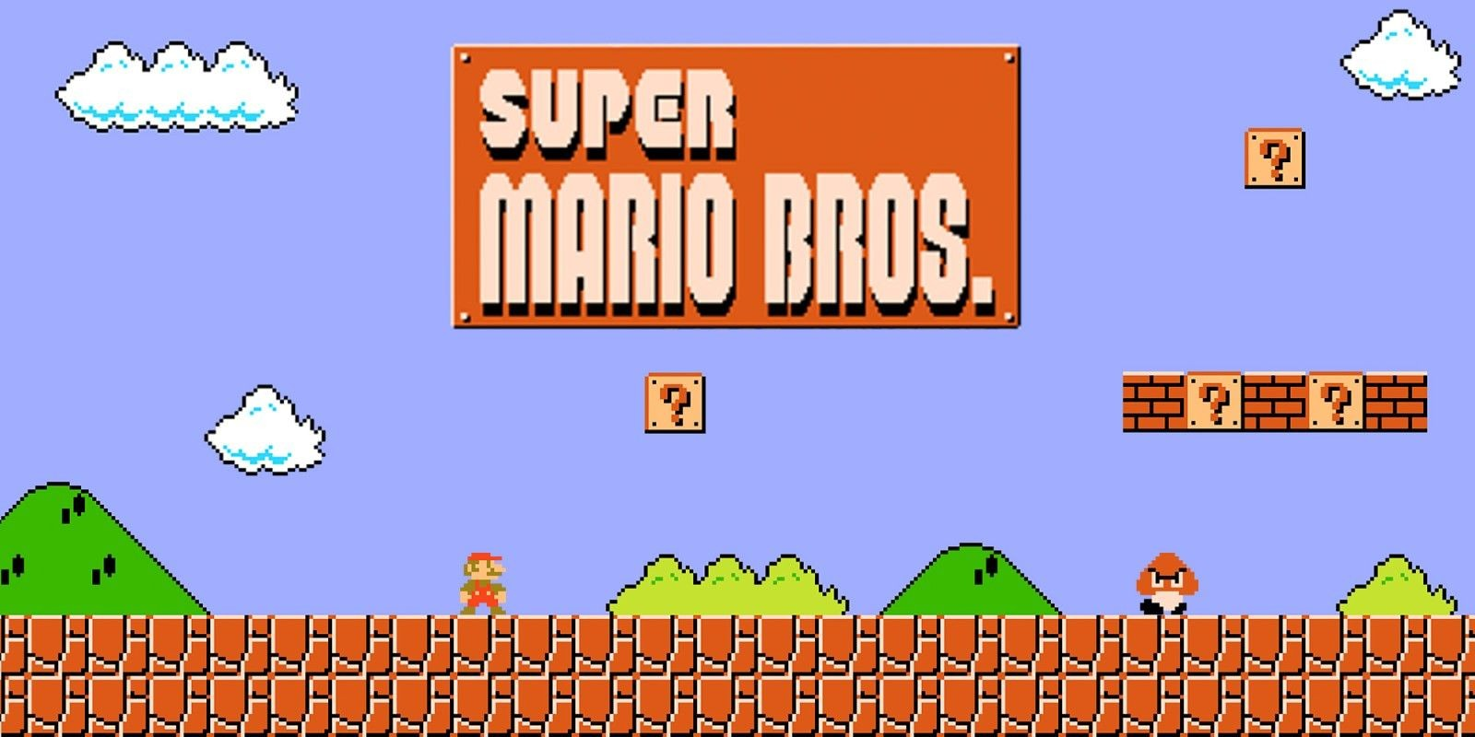

Fig. 15. *Super Mario Bros.* level 1 (Nintendo).

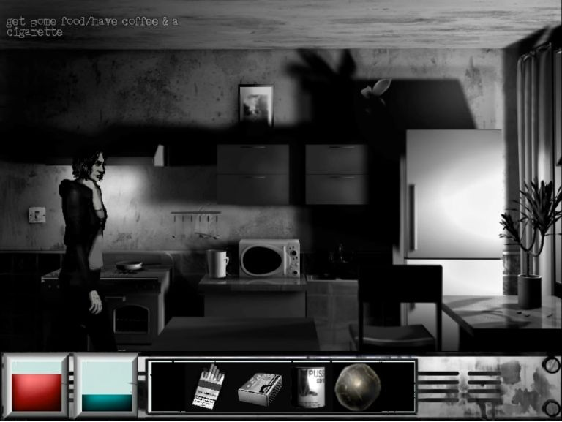

Fig. 16. *The Cat Lady* coffee level (Harvester Games).

**Part 3: Narrative-centric design with *The Toymaker’s Bequest***

Now, with all of this discussion about narrative-centric games, I would like to finish off with an example of developing a narrative-centric game, *The Toymaker’s Bequest*, as well as some lessons learned from the experience. *The Toymaker’s Bequest* has been developed in collaboration with Yiwen Dai as a joint thesis project.

* 1. *Concept*

Briefly describing the game, designed for those struggling with the inescapable rat race which is life, *The Toymaker’s Bequest* is a vignette based interactive narrative experience

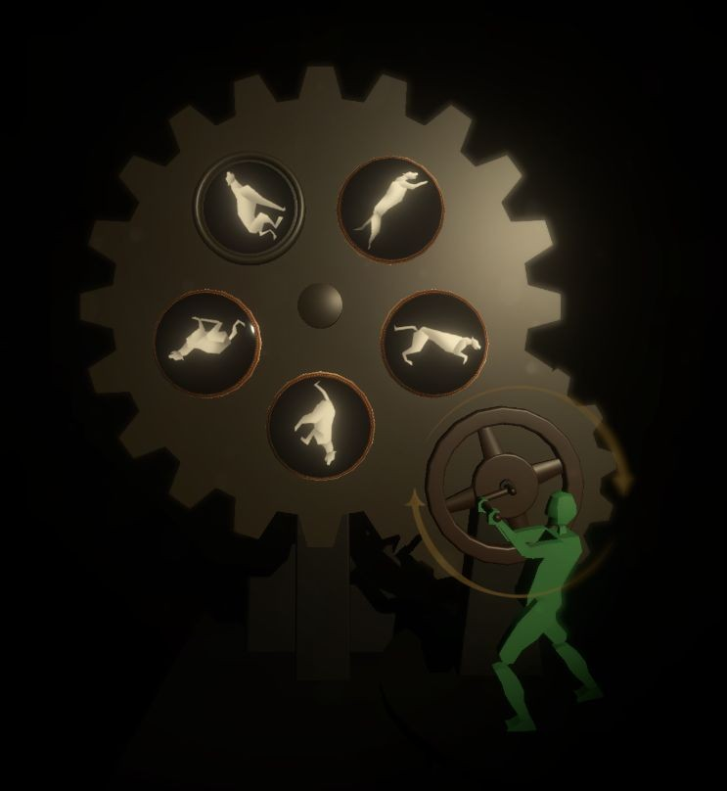presented as hand crafted toys (see fig. 17). These toys portray a fantastical story about the everyday struggles of a woman living in an intolerant society and her attempts to reconcile with her past through her creations (see fig. 18).

Fig. 17. Interactive zoetrope in *The Toymaker’s Bequest*.

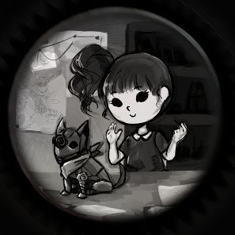

Fig. 18. Interactive peephole portraying the main character’s life in *The Toymaker’s Bequest*. Art by Renzel Navarro.



Fig. 19. Opening Sequence in *The Cat Lady* (Harvester Games).

* 1. *Prior Art for narrative design*

*The Cat Lady*, as I have mentioned above, is a psychological horror adventure game, by Harvester Games, about a chronically depressed, middle aged woman, that is thrown into undesirable situations after she tries to take her own life (see fig. 19). This game has served as one of the cornerstones for narrative progression where a sense of the world is established through seemingly pointless interactions with the scene. With a heavy reliance on enacted narratives, the plot is moved forward by the player performing appropriate actions based on a broadly defined goal.

*The Sensational December Machine* is an interactive short story developed by Simogo (see fig. 20). This game tells a story about an inventor that creates a machine designed to touch people’s hearts and the criticism she receives for the seemingly pointless purpose of the machine. Taking inspiration from the meta-critique of the perception of games through the fictional world of the inventor, *The Toymaker’s Bequest* is an attempt to further explore the expressive qualities of examining a character’s creative works.

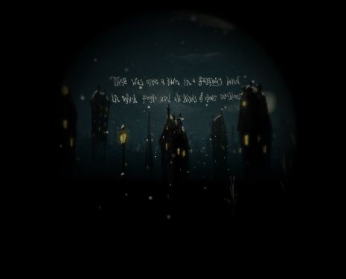

Fig. 20. Stills from *The Sensational December Machine* (Simogo, “Sensational”).

*What Remains of Edith Finch* is a vignette based narrative-centric game about uncovering the stories surrounding a cursed family (see fig. 21). This game’s narrative structure of loosely interconnected vignettes with an unreliable narrator over a consistent theme as well as the blending of text and unique interactions to emphasize the delivery of story greatly influenced the development direction of *The Toymaker’s Bequest*.

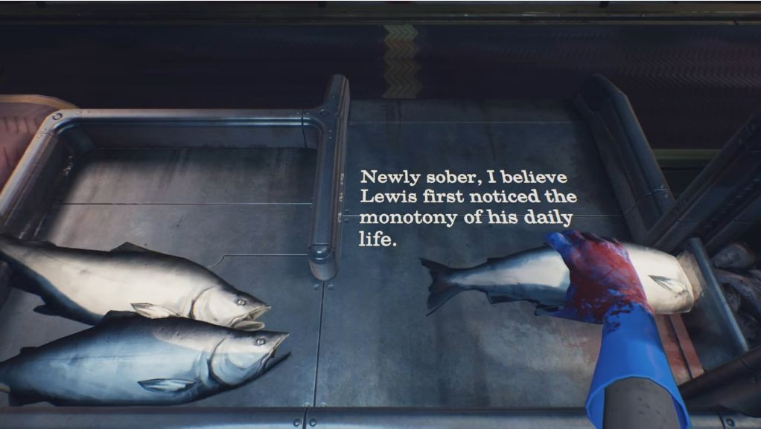

Fig. 21. Still from the cannery in *What Remains of Edith Finch* (Giant Sparrow).

* 1. *Design Methodology*

# Ideation

The idea for *The Toymaker’s Bequest* began with a desire to tell a story through puppetry and automata. Though mostly out of personal interest, the development team found intrigue in the aesthetics and feeling of puppetry in its unique, almost theatrical, mode of storytelling.

With this in mind, designing *The Toymaker’s Bequest* began with defining narrative experience goals. This being the definition of the themes and feelings intended to be evoked from the game experience. The specifics of the story may be written to help convey the feeling, but the story was expected to change as development progressed. For *The Toymaker’s Bequest*,

the goal was to convey a story of self-acceptance that would follow an emotional arc of regretful disdain to redemptive self-acceptance.

With this narrative experience goal in place, the next step was to establish the interaction design goals based on what interactions promoted possibilities for the desired narrative experience. It is important to note that the desired narrative experience is not a specific scene or narrative spectacle, rather it is a general feeling or theme so as not to prematurely limit the game’s potential and compromise the original vision. In this regard, *The Toymaker’s Bequest* opted for the feeling of playing with mechanical toys to enhance the feeling of rummaging through another’s belongings to discover the secrets hidden within. The interactions were designed as general gestures of clicking and turning a crank to simulate mechanical actions (see fig. 22 and 23).

By the end of the ideation phase, the development team had established a narrative experience goal and general interaction mechanic. To get to this process, a variety of narrative and mechanical prototypes were created to narrow down the options, both of which served as a means of conveying an idea rather than to serve as the final product.

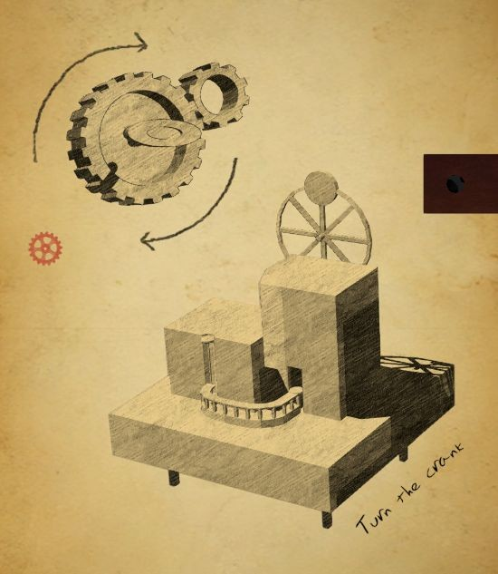

Fig. 22. Still detailing interaction mechanic from *The Toymaker’s Bequest.*

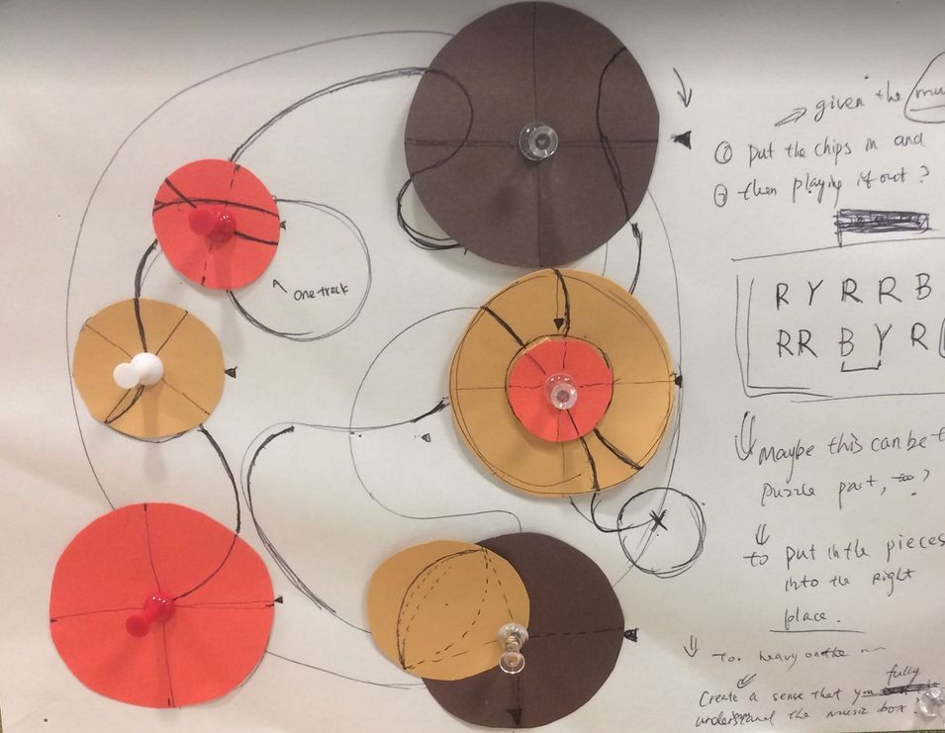

Fig. 23. Paper prototyping of the interaction mechanic.

# Pre-production

The same as any other game, in pre-production, the goal was to create a vertical slice. The vertical slice is a small polished unit of the game showcasing the game’s end goal. For a narrative-centric game, the vertical slice could be the narrative progression mechanic just as a mechanical vertical slice may be the traversal mechanic. In *The Toymaker’s Bequest*, the progression mechanic was the click and turn interactions that would trigger further narrative content. Importantly, this progression mechanic alone, without the narrative, would not be sufficient as a vertical slice as it would be taking a game element out of context. Each game element is not meant to function as a standalone game. Consequently, it is easy to fall prey to over-focusing on perfecting the mechanical interaction to the detriment of narrative delivery. Since having the full narrative would be difficult at such an early stage of development, the goal is to incorporate the smallest unit of narrative content, or an emotional beat. For *The Toymaker’s Bequest*, the team focused on the introduction scene of a single level of the game. The vertical slice incorporated a view of the mechanical toy and the first few moments of interaction that included the introduction of the premise and the establishment of the tone (see fig. 24).

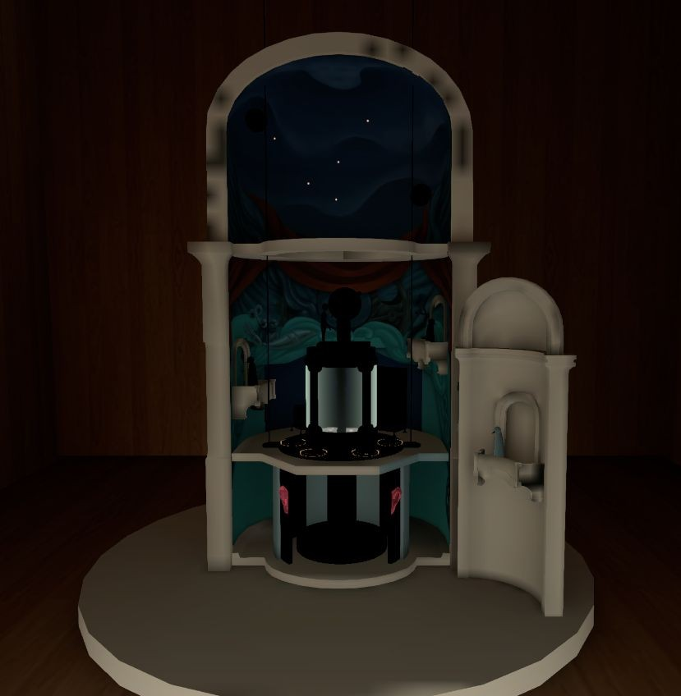

Fig. 24. Mechanical toy view of *The Toymaker’s Bequest’s* vertical slice.

Though not quite entering full production, another process that occurred during pre-production is the narrative prototype. This prototype would not be concerned with

mechanical interaction but instead focuses on establishing the overall scope of the story as well as defining the story’s tone. For this prototype, as long as the entire narrative is included, it can take any form such as storyboards, paper prototypes, or hypertexts. For *The Toymaker’s Bequest*, I used an open source HTML based tool, Twine, to create the narrative prototype, simulating the progression mechanics through links that described the action that were to take place (see fig.

25).

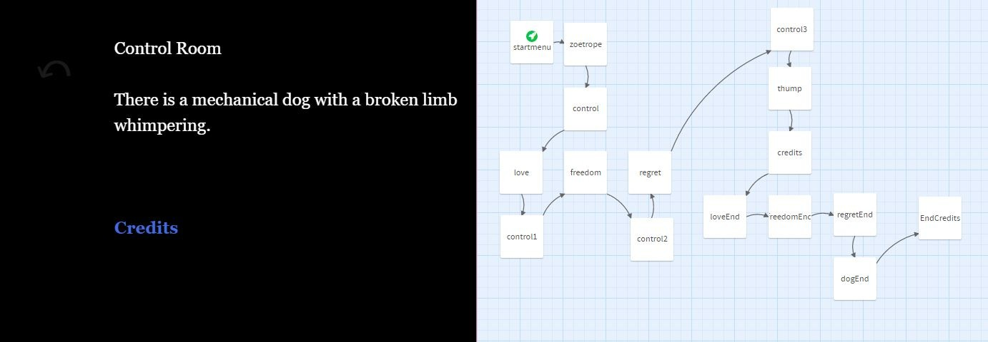

Fig. 25. Narrative prototype of *The Toymaker’s Bequest* utilizing Twine*.*

In the pre-production phase, it is important to try to be as detailed as possible about the project’s forward trajectory, but it is of greater importance to acknowledge the iterative process. As it has been discussed previously, to avoid the typical pitfalls of narrative-centric game development like ludonarrative dissonance, it is crucial to remain flexible and adapt to changes. For example, *The Toymaker’s Bequest* has seen at least four major overhauls. In its current iteration, the game no longer resembles the original narrative prototype, but the team is in consensus that the project has been refined to more effectively achieve the experience goal.

# Production

Just as any other game, full production begins by working towards the game’s alpha, where the core game loop is established with all core content stubbed in. For a narrative-centric game, this means that a critical path for narrative delivery is established. To be more specific, all

narrative content along with their respective interactions need to be stubbed in for a comprehensible narrative delivery.

Narrative-centric games usually take longer to reach alpha because narrative moments tend to have unique interaction requiring specialized development. Despite this, it is frequently necessary for narrative-centric games to have a functioning narrative in the game as soon as possible. Designing narrative-centric games addressing player agency and engaging in systemic design is rarely a straightforward experience of putting in the right narrative content. Instead, it is an iterative process of trial and error by which the developer constantly compares their desired narrative experience with the player’s narrative comprehension.

A workaround to the longer narrative development times in narrative-centric games is to stub in narrative in the form of placeholder text or inelegant prose. Rather than telling a story elegantly, the goal is to clearly tell a story quickly to begin an overall evaluation of the game.

The rule the development team of *The Toymaker’s Bequest* used was to aim for over-explaining everything in the simplest method so that the team could guarantee a baseline comprehension of the narrative by alpha (see fig. 26). There is likely to be residual desires to perfect each narrative moment as you go, but this is likely to stunt progress over work that is not guaranteed to remain later. Any polish work can be saved for later as it is far easier to pinpoint areas of improvement in an inelegant delivery of a comprehendible narrative than it is to work with confusing or missing narratives.

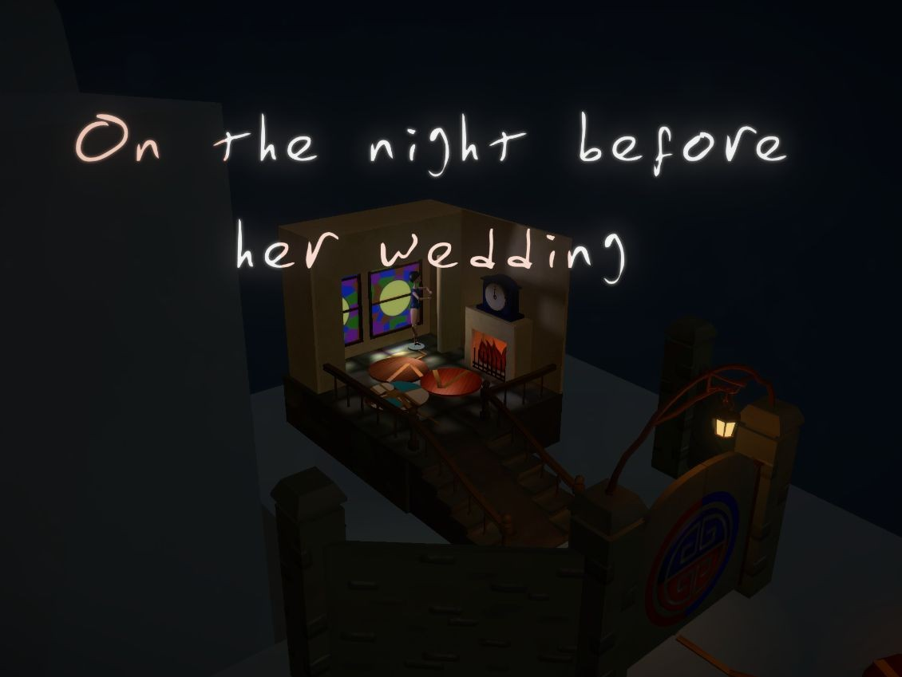

Fig. 26. Text stubbed in for narrative delivery in *The Toymaker’s Bequest’s* music box level.

Once the game reaches alpha, the game should be at a functional state where narrative comprehension is occurring clearly. It is possible, even expected, that the game will seem boring with a weak emotional impact or player agency. For *The Toymaker’s Bequest*, a common criticism was how the game felt generic without any expressive qualities to draw the player in.

As discouraging as these comments may feel, the game is still far from being finished at alpha. The alpha is about reaching a functional core that can be fleshed out. As such, the next stage of production is to begin fleshing out the game with embedded content, narrative refinement, interaction feedback, etc. Basically, it is a chance to incorporate anything that would add an expressive flare to the generic feeling game.

Specifically, in *The Toymaker’s Bequest*, the team decided to utilize embedded narrative content with optional interactive moments in the scene to promote exploration by rewarding the player with narrative depth. For example, the scene where a magic show occurs would have posters lining the walls detailing the performance (see fig. 27).

From this point on, the development process for a narrative-centric game mirrors that of any other game with frequent playtests and continuous refinement of existing content until the game is deemed finished. At the time of writing this paper, *The Toymaker’s Bequest* is still in development but in the following section I will detail some playtest feedback for evaluation.

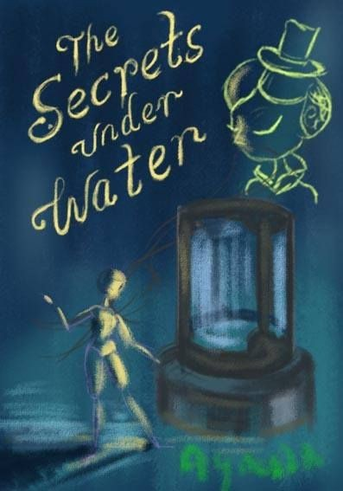

Fig. 27. Poster as embedded narrative in *The Toymaker’s Bequest’s* theatre level.

* 1. *Feedback*

Just like any other game, a developer cannot anticipate all possible player interactions with a game and requires frequent playtests to evaluate and refine the experience. Especially with narrative-centric games engaging in authorial design, it is important to gauge whether the intended experiences are being conveyed. In addition, player feedback is important in getting a glimpse into the player’s perceived agency within a narrative system.

For this section, I will discuss the playtest feedback the game has received, focusing on the comments that specifically pertain to the narrative elements of the game. Overall, the comments received showed an incremental progress towards clarity with some divergence in player’s personal preferences. However, a major shift was noticed after the game reached alpha. In the following I will discuss differences in feedback from pre-alpha to post-alpha stages of the game.

# Pre-alpha

In the stages before reaching alpha, most people found the game confusing without being able extract much meaning from the content presented. The players were able to guess what type of emotions the game was trying to convey, but the specifics of the story were not clear. As a result, most interactions felt random or too simple. In hindsight, most of the feedback pertaining to interactions were misleading as the interactions were evaluated for its independent worth rather than its value in conjunction with the narrative.

# Post-alpha

Once the game reached alpha, major changes occurred in four ways. First, all pre-existing content was seen with all necessary contextual information leading to informed interpretations.

For example, the action of the player clicking on a chest to reveal what was inside seems random without any context. In contrast, when presented with information that an escape performance is taking place, the chest receives new meaning as a performative tool as well as invoking a sense of curiosity (see fig. 28).



Fig. 28. Chest interaction revealing a frog in *The Toymaker’s Bequest’s* theatre level.

Second, players were able to form opinions and informed feedback on whether a narrative element worked or not. This point relates to why it is crucial to stub all narrative content in the alpha as player’s can evaluate the success of the game’s experience goal.

Third, players’ judgments of the mechanical interactions were changed. Now that there was narrative content paired with the mechanical interactions, each element could be judged by how well it fit the whole. As for *The Toymaker’s Bequest*, players were more forgiving and sometimes preferred the simple mechanical interactions as they did not distract from the narrative. Also, the seemingly random interaction no longer felt as random because the narrative elements served as hints to the next desired interaction.

Finally, players’ were able to construct their own mental map of the game’s narrative, or in other words they were able to extract their own meaning and formulate hypothesis on what is supposed to happen next. *The Toymaker’s Bequest* is a game that offers pleasure in a similar way as one may find pleasure in reading a story. The player interacts with the presented narrative information at a conceptual level as they attempt to comprehend and map out the narrative space. From this map, a player is then able to make informed decisions on likely progressions that can be confirmed or subverted based on the author’s intentions. A simple example of how this mode of play can offer pleasure is in a sequence in *The Toymaker’s Bequest* where the player is watching an escape performance play out. The player partakes in the actions of guiding the performer into a water tank, closing the doors, and waiting to reopen the doors to find that the performer has disappeared (see fig. 29). At this point, the player is free to traverse and interact with the level and in a few play tests, the team observed players beginning to make guesses on what is supposed to happen next. They took a look at the space or embedded content, trying to

take in as many clues from the world to understand what is going on, until deciding that the most likely reappearance for the performer was to occur in a conspicuously placed closet. The player would click to open the closet doors to reveal the performer, confirming the player’s expectations with a rewarding narrative progression (see fig. 30). It was reported by many players that it was a pleasurable experience when their mental model of the narrative was confirmed by the game system through appropriate feedback from the game.

Overall, the main shift in player feedback was in the player’s ability to conceptually engage with the game beyond its formal elements. And for a game that, at its core, wanted to use a story to promote thought and convey a message, this was a major milestone towards the desired player experience.

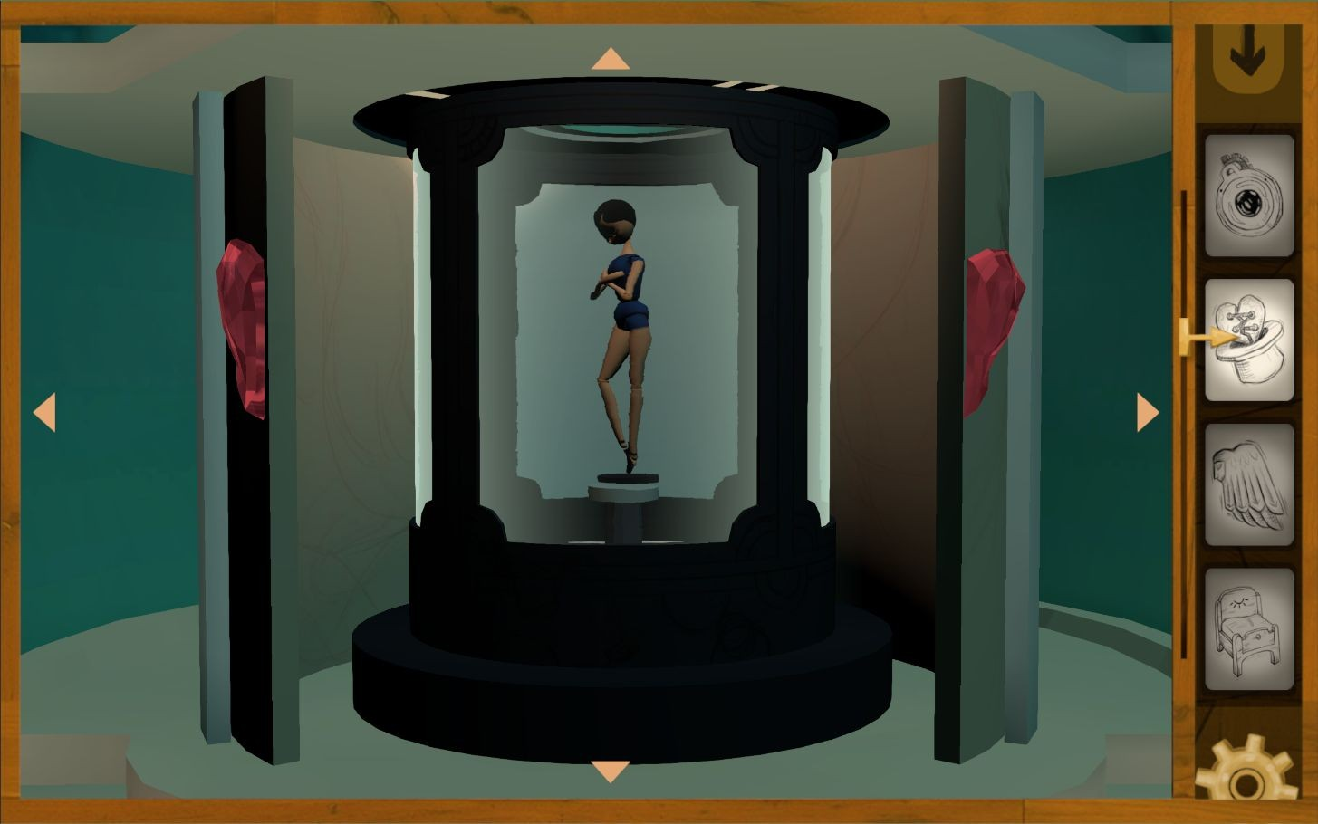

Fig. 29. View of the water tank in *The Toymaker’s Bequest’s* theatre level.

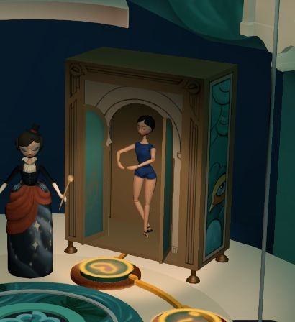

Fig. 30. Character’s reappearance upon interacting with the closet in *The Toymaker’s Bequest*.

* 1. *Lessons and Difficulties*

At the time of writing this paper, *The Toymaker’s Bequest* is still in development but here are some of the lessons and difficulties that have surfaced in creating a narrative-centric game.

# Scope

The biggest lesson learned is that the scope of a narrative-centric game can grow drastically as the complexity of the story increases. A narrative-centric game is not only about

moving from one plot point to another, but it is also establishing the meaningful interactions and spatial navigation to offer depth to the plot elements. Making a vertical slice is a good way to figure out how long creating narrative content takes for planning ahead, but it is good to be wary of how easy it is for a narrative-centric game to become unmanageable.

# Clarity & Simplicity

A major lesson learned is that games are not necessarily the best medium for telling complex stories through subtlety. In addition, having clarity and simplicity does not dilute the impact of the story. *The Toymaker’s Bequest* team learned this the hard way as the team struggled to tell a complex story about interpersonal conflicts with aesthetic, yet not really explicit, prose. Most of the meaning got lost to the players that were distracted by the mechanical interactions. Eventually, the team decided to implement clear text with an obvious introduction of contextual information with repeated exposure of important plot points. Furthermore, the narrative was rewritten to simplify character motives to easily understood emotions. As one dimensional as this may seem, the results were far superior with the clear and simple approach with players having enough initial understanding of the narrative to begin layering their own depth with embedded clues and hypothetical interpretations.

# Generic vs. Expressive

Another point of pain was the struggle to make generic content become expressive.

Attempting to make plot points clear, the writing for *The Toymaker’s Bequest* took on a

functional approach. Each event was described as it occurred, but the players’ began questioning why they were reading the same content that was being visually shown. As a result, the team took an approach to use textual information as a means to add an emotive layer on top of the functional event that was happening. For example, the narrator of *The Toymaker’s Bequest* used to have an omniscient voice that talked directly to the player as if they were a guide to the game world. This method proved to be difficult in portraying the narrator as a character with her own goals and emotions. Instead, in a newer pass of the writing, the narrator takes on a character that is frustrated with past events and seeks creative expression as a means to rant about her past.

This adjustment in character motive allowed for the narrator to deliver exposition tinted with a hint of anger and solemn regret that ultimately enhanced the game’s expressive delivery.

# Work vs. Play

The final lesson from developing *The Toymaker’s Bequest* came in the difficulty of integrating mechanical interactions with narrative content without making one feel like work. Similar to how many gamers express their distaste for cutscenes in action games, the team found that a narrative-centric game may suffer the problem of the mechanical interaction feeling like busy work when the narrative content is what the player wants. Though there is no clear solution to this problem, a few tricks *The Toymaker’s Bequest* team managed to pick up were to test the mechanical interactions early with the narrative, that simple interactions are likely sufficient for narrative-centric games, and that mechanical interactions do not need to perfectly solve ludonarrative dissonance but it does need to involve narrative stakes in some capacity.

Expanding the last point, the team settled on a mechanical interaction that has been described as the fourth wall mechanic. A fourth wall mechanic is a progression mechanic that is not directly impacting the direction of narrative progression. Instead, the interaction exists outside of the narrative space, in a fourth wall space, where the player only pulls a lever to move the story forward. What is unique and compelling about the fourth wall mechanic is that the fourth wall interaction requires the player to make informed decisions on their next action while keeping the player invested in the outcome of the action by tying the outcome with the player’s goals. In *The Toymaker’s Bequest*, the team settled for a player interaction that mirrors the act of tinkering with old mechanical toys that tell stories of their creator (see fig. 31). Operating the toy would not change the story, but it would keep the story moving. Each interaction was informed by the plot and the resulting outcome provides additional information about the narrative space as well as revealing new clues towards the ultimate goal of understanding the motives behind the elusive toymaker. Though the success of implementing the fourth wall mechanic in *The Toymaker’s Bequest* is up for debate, the fourth wall mechanic model is a compelling model for gauging whether an interaction in a narrative-centric game serves any purpose.

# Conclusion

Even though the process of developing *The Toymaker’s Bequest* was a bumpy journey, it has without a doubt been a fruitful one. The struggle to design a narrative-centric game proved to be a worthwhile endeavor in creating a game experience unique in content, especially with Jenkins’ spatial narrative models. As mentioned before, though *The Toymaker’s Bequest* is still in development, there has been enough evidence from play tests that a narrative-centric design

model is a viable means to develop interactive experiences. The abundance of narrative-centric games that are already in existence also serve as evidence for the viability of narrative-centric games. Therefore, I would like to end this discussion with a hope to encourage more game developers to pursue narrative-centric game development so that there may be a greater diversity in game experiences, ultimately pushing the boundaries of the games medium.

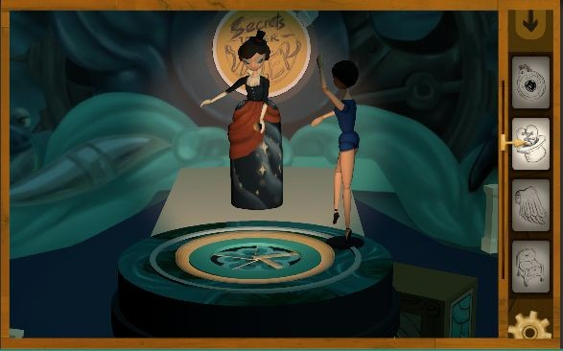

Fig. 31. Opening sequence of *The Toymaker’s Bequest’s* theatre level.

# Works Cited

Aarseth, Espen. *Cybertext: Perspectives on Ergodic Literature*. Baltimore, Md.: Johns Hopkins University Press, 1997.

Barlow, Sam. *Her Story*, 2015. Computer Software.

Bogost, Ian. "Video Games Are Better Without Stories." *The Atlantic*, 25 Apr. 2017, [www.theatlantic.com/technology/archive/2017/04/video-games-stories/524148/.](http://www.theatlantic.com/technology/archive/2017/04/video-games-stories/524148/)

“Commedia Dell' Arte.” *Joukowsky Institute for Archaeology & the Ancient World*, Brown University, [www.brown.edu/Departments/Joukowsky_Institute/courses/13things/7731.html.](http://www.brown.edu/Departments/Joukowsky_Institute/courses/13things/7731.html)

Corrigan, Marianne, and Ash Ogden. "Explorations in the Ergodic." *Alluvium*, 25 Mar. 2013, dx.doi.org/10.7766/alluvium.v2.2.01.

Giant Sparrow. *What Remains of Edith Finch*. Annapurna Interactive, 2017. Computer Software. Haggis, Mata. "5 Answers About Why There is a Conference for Queer Gamers." *Matazone*

*Games*, 20 July 2013,

games.matazone.co.uk/5-answers-about-why-there-is-a-conference-for-queer-gamers/.

Harley, Jason M., et al. "Designing Story-Centric Games for Player Emotion: A Theoretical Perspective." *AIIDE Joint Workshop*, 2015.

Harvester Games. *The Cat Lady*. 2012. Computer Software

Hocking, Clint. "Ludonarrative Dissonance in Bioshock." *Click Nothing*, 7 Oct. 2007, clicknothing.typepad.com/click_nothing/2007/10/ludonarrative-d.html.

“House of Leaves.” *Goodreads*, Goodreads. Inc,

i.gr-assets.com/images/S/compressed.photo.goodreads.com/hostedimages/1425227260i/1 3864564.jpg.

"How To Start Your Game Narrative - Design Mechanics First - Extra Credits." *YouTube*, [uploaded by Extra Credits, 7 Feb. 2013, www.youtube.com/watch?v=22HoViH4vOU.](http://www.youtube.com/watch?v=22HoViH4vOU)

Irrational Games. *BioShock*. 2K Games, 2007. Computer Software. Irrational Games. *BioShock Infinite*. 2K Games, 2013. Computer Software.

Jenkins, Henry. “Game Design as Narrative Architecture.” Noah Wardrip-Fruin and Pat Harrigan, ed. *First Person: New Media as Story, Performance, and Game*. Cambridge: The MIT Press, 2004. 118-130. Print.

Meadows, Donella H., and Diana Wright. *Thinking in Systems: a Primer*. Chelsea Green Publishing, 2015.

Mountains. *Florence*. Annapurna Interactive, 2018. iOS

Naughty Dog. *The Last of Us.* Sony Computer Entertainment, 2013. PlayStation 3. Naughty Dog. *Uncharted 3: Drake’s Deception.* Sony Computer Entertainment, 2011.

PlayStation 3.

Nintendo Creative Department. *Super Mario Bros.* Nintendo, 1985. Nintendo Entertainment System

Oh, Sanghee. *The Return: A Case Study In Narrative Interaction Design*. 2013. University of Southern California, MFA thesis.

Simogo. *Device 6*. 2013. iOS

Simogo. *The Sensational December Machine*. 2014. Computer Software.

Stobbart, Dawn. *On Videogames: Representing Narrative in an Interactive Medium*. 2016.

Lancaster University, PhD dissertation.